KTI Safety Alert SA2G
INSTRUCTIONS FOR USE
To Activate
Slide the RED protective cover downwards to access the Activation button
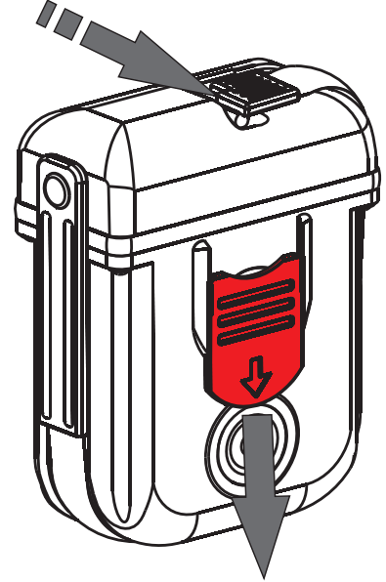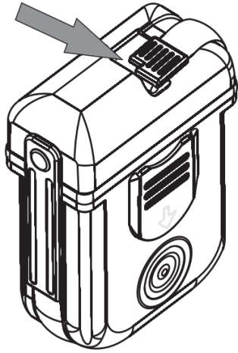
Release the antenna end lock by sliding the clip towards the front.
For best transmission the antenna needs to be twisted to 90 degrees from the body so that the antenna is pointing skywards. Keep your hands away from the antenna as this will reduce it’s transmission effectiveness.
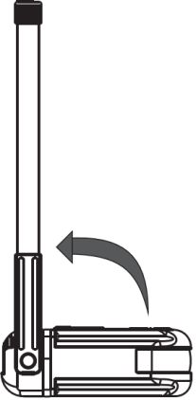 Push the RED Activate Button 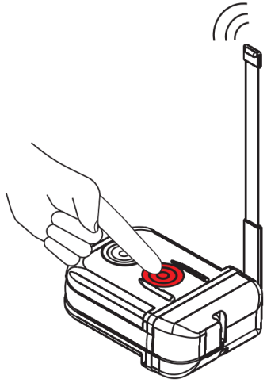
until the green and white lights start flashing
At this point stay where you are. The Personal locator beacon sends your GPS location and this is used by your rescuer. If you move they may not be able to find you as quickly. The rescue team will switch the PLB off when they have found you
How do 406 MHz distress beacons work?
When a 406 MHz distress beacon is activated it transmits a digital signal that can be detected by a series of stationary and orbiting satellites called the Cospas-Sarsat satellite system. These satellites listen for any active beacons and report the beacon position to the appropriate rescue authorities. The stationary satellites are 30,000 km from the earth in the northern sky and if they receive the signal the rescue coordination centre is notified immediately this happens when you have a clear view of the northern sky. The Low orbit satellites pass over head about every 90 mins and are only 800 km high, they can pick up signals in heavy forest and down ravines
Beacons developed for Cospas-Sarsat operate on the 406 MHz frequency and use digital technology to transmit a unique code (Hex ID or UIN) which enables the rescue authorities to identify the beacon. The beacon will also transmit on the 121.5 MHz frequency. This signal can be picked up by overflying aircraft and is primarily used by rescuers to "home in" on the beacon's location.
The Cospas-Sarsat satellites provide a close estimate of the beacon position which can be used to send rescuers into the right region and then the 121.5 homing frequency can be used to guide the rescuers to the exact beacon position.
Most distress beacons also have the ability to transmit their GPS position which provides rescue authorities with a much more accurate position fix for the beacon.

